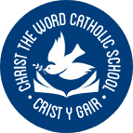
Ysgol Crist Y Gair
Rhyl
Christ the Word Catholic School

We lay the foundations of Kindness, Forgiveness, Respect and Integrity.
Safeguarding information f for learners

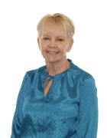
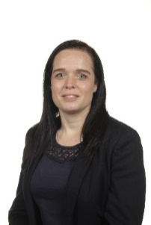





Mr White- Deputy Headteacher
Miss Feliciello – Interim Headteacher
Mrs Shute- Deputy Designated Safeguarding Person
Mrs Mackenzie-Chadwick – Associate Assistant Headteacher
Mrs Logan- Assistant Headteacher
Mrs Weir – Behaviour Manager
Miss Glover- ALNCO
Mrs Austin – Assistant Headteacher/ Deputy Designated Safeguarding Person
Are you worried about someone, or is there something worrying you? Who can you tell?
Your worry could be related to home or school, it may even be a concern for someone else, what you have seen or what someone has told you.

Safeguarding Team
What happens when I share my concerns?

Most importantly, you will be listened to and your concern will be taken seriously and dealt with confidentially. If your concern is raised to someone who is not part of the Safeguarding Team, they will need to share this with a member of the Safeguarding Team who will provide support and communicate with you about the next steps.
You may have a staff member in school who you feel more comfortable with to speak to about your concerns or worries. But if you are not sure there are staff in school who are part of the Safeguarding Team who can help you. They are listed at the bottom of this poster.
All staff are safeguarding trained. It is every member of staff’s responsibility to safeguard you.
EVERYONE has a duty of care to ensure you are safe.

