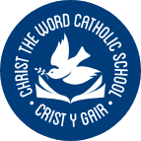
Ysgol Crist Y Gair
Rhyl
Christ the Word Catholic School

We lay the foundations of Kindness, Forgiveness, Respect and Integrity.
Safeguarding is everyone’s responsibility. It is everyone’s job to keep children safe.

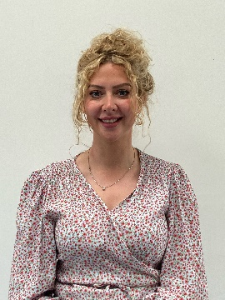
Designated Safeguarding Person If anyone has any concerns about the health & wellbeing of any pupil, they should contact the Designated Safeguarding

Person immediately.

Mrs S. Shute
Designated Safeguarding Person
Person Diogelu Dynodedig

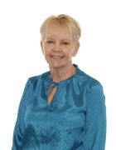
If unavailable, please contact:
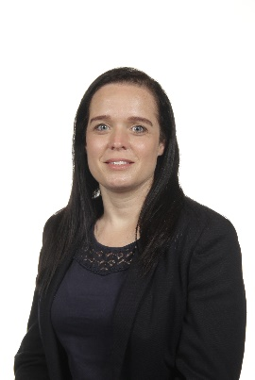

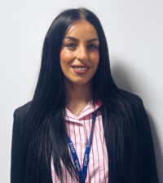

Mrs R. Austin
Assistant Headteacher/ Deputy Designated Safeguarding Person Pennaeth Cynorthwyol / Dirprwy Berson Diogelu Dynodedig

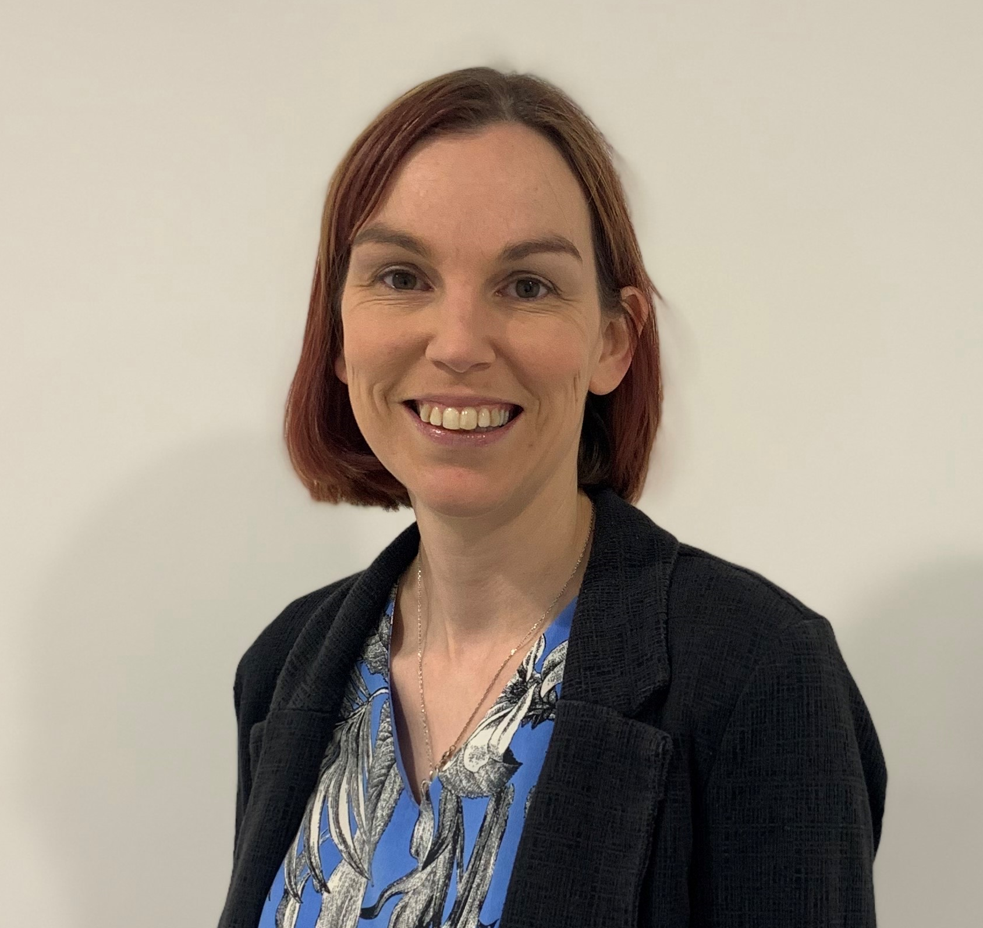

Miss L. Feliciello
Interim Headteacher
Pennaeth Dros Dro

Mrs J. Weir
Behaviour Manager
Rheolwr Ymddygiad

Ms J. Glover
ALNCO Cydlynydd Anghenion Dysgu Ychwanegol (CADY)

Mrs A. Mackenzie- Chadwick
Associate Assistant Headteacher Pennaeth Cynorthwyol Cyswllt
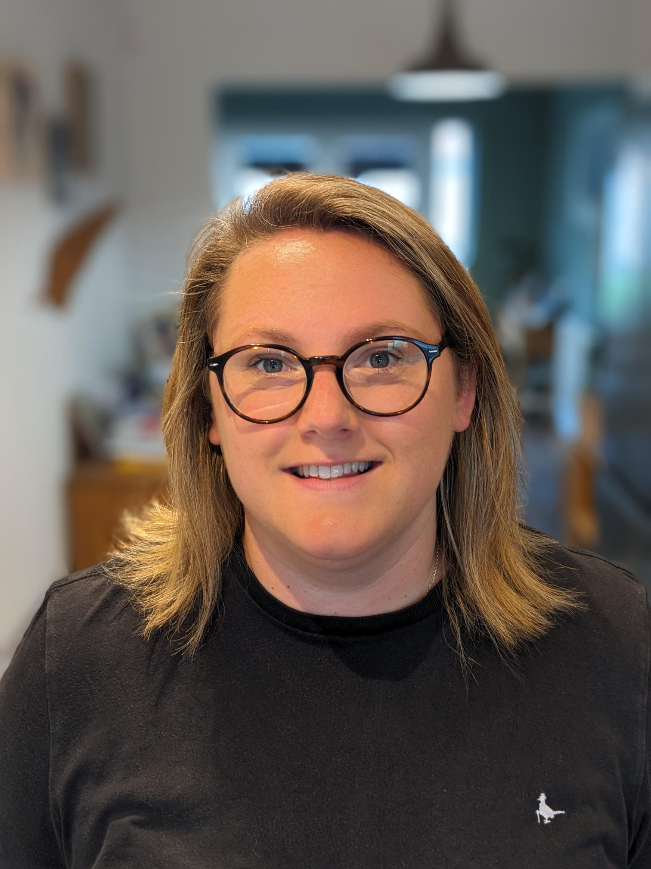
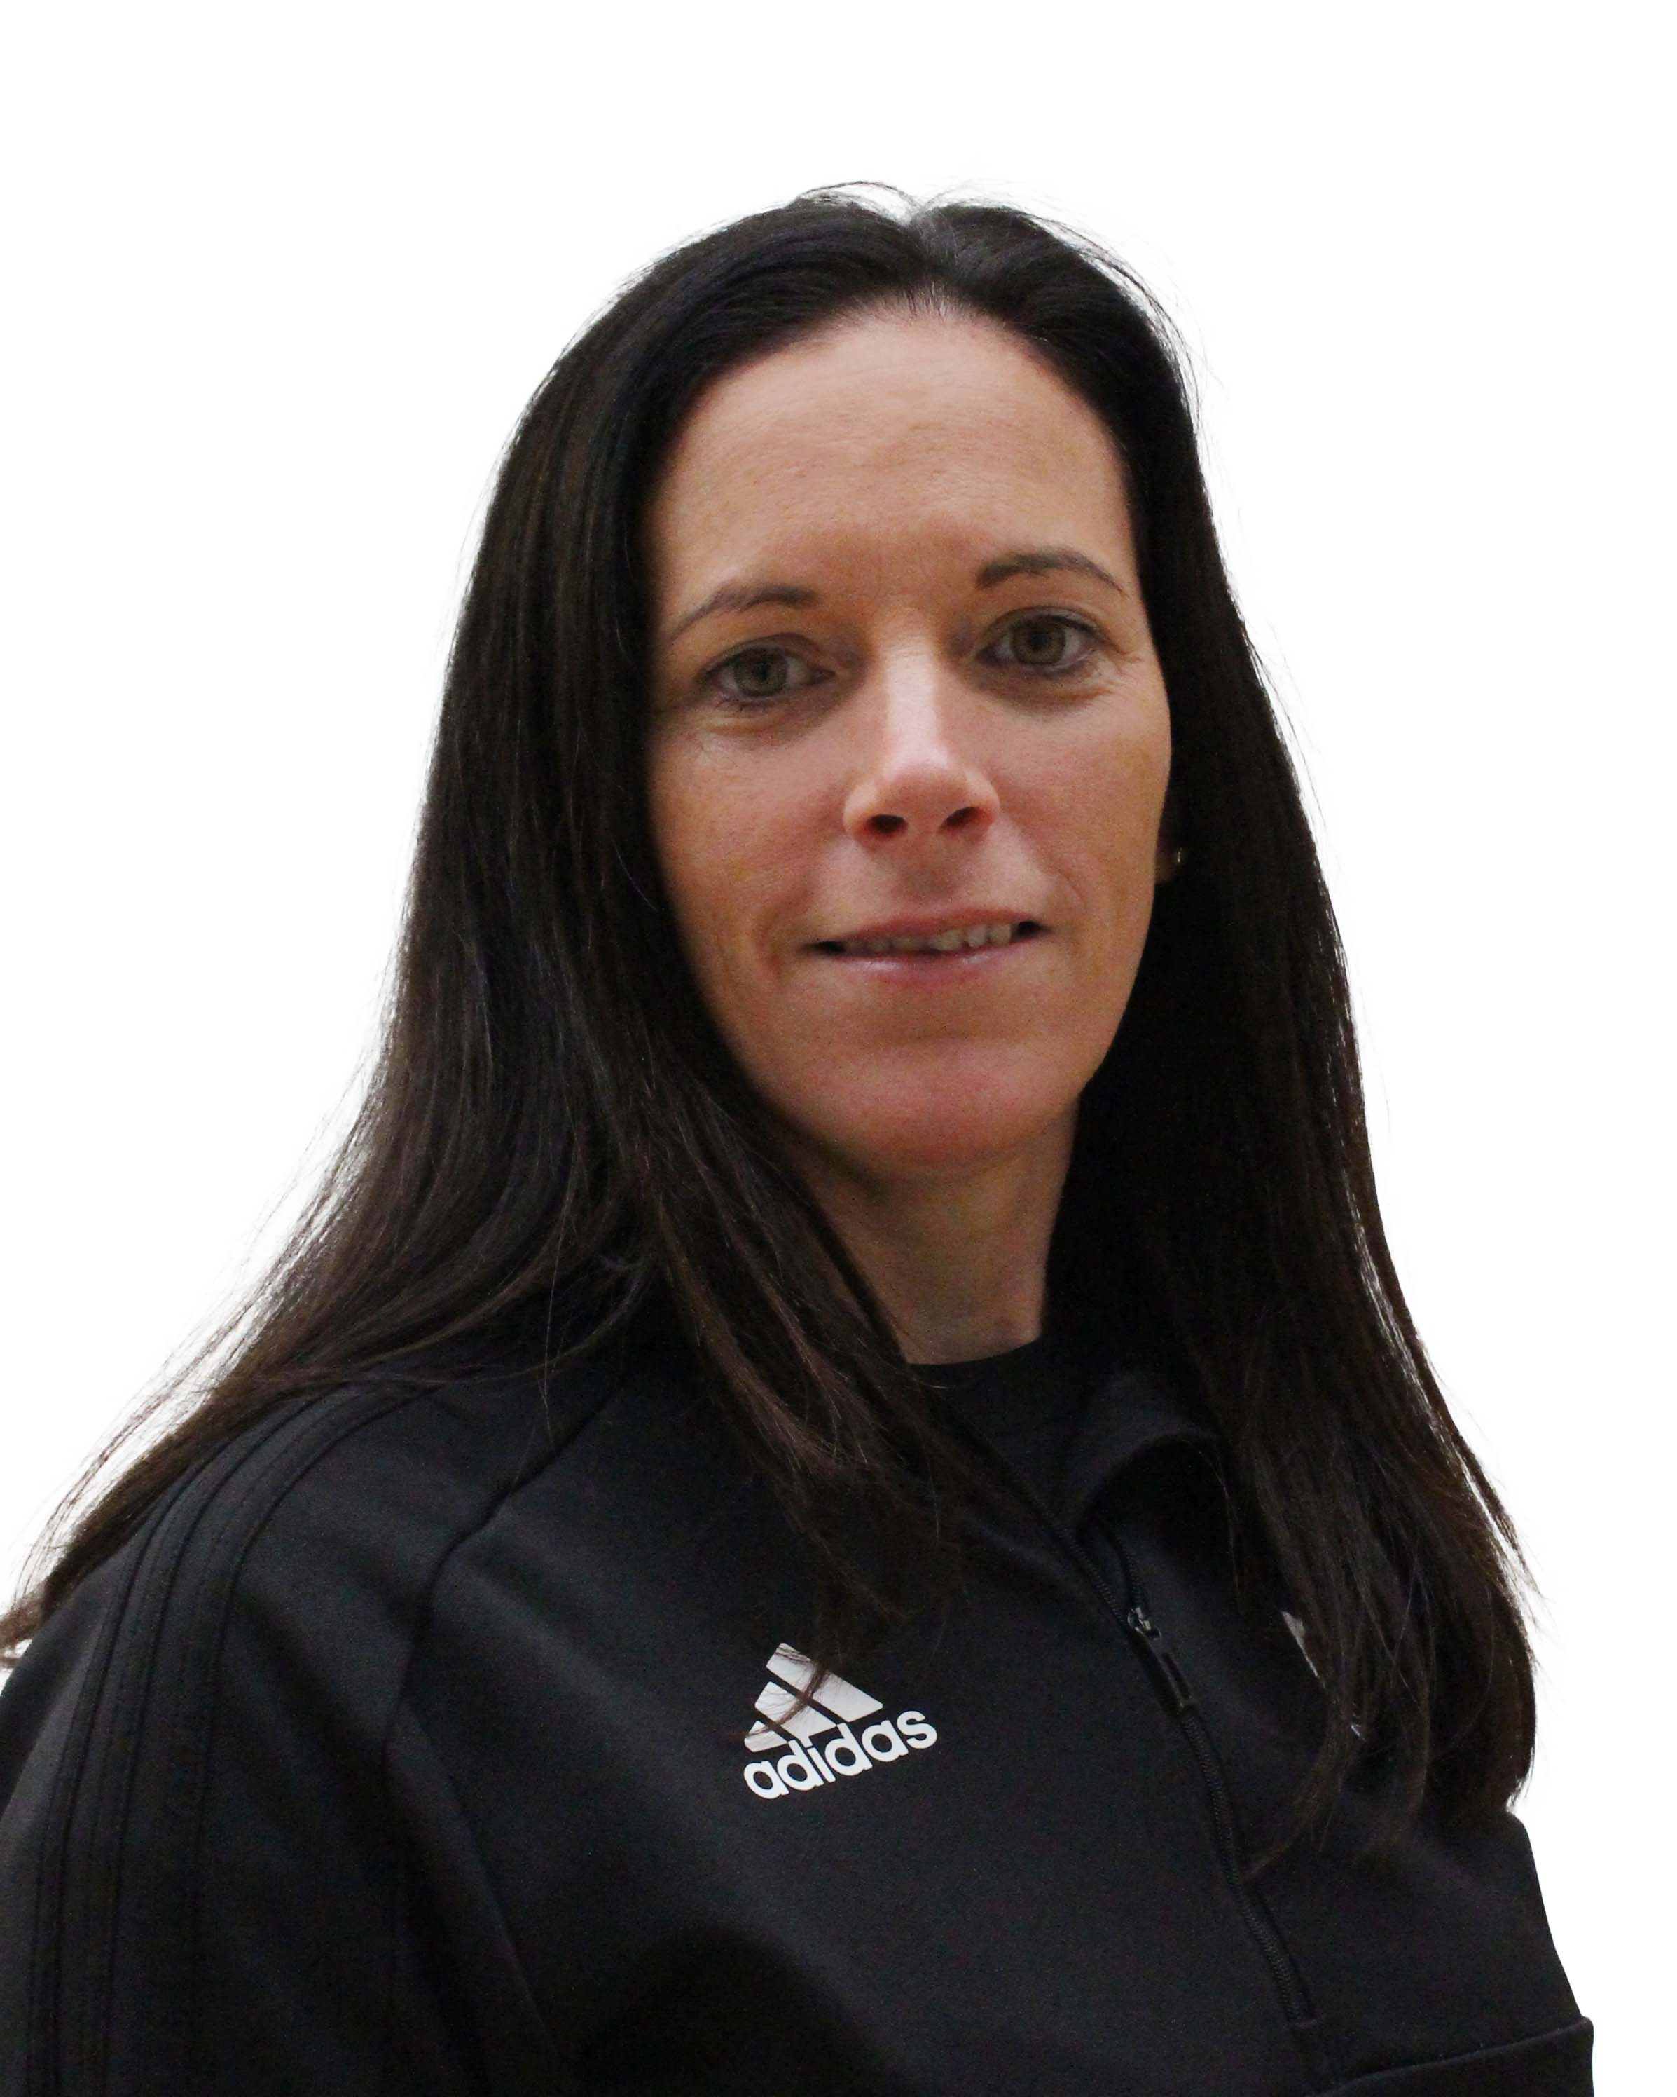


Mrs N. Logan
Assistant Headteacher
Pennaeth Cynorthwyol

Mr J. White
Deputy Headteacher
Dirprwy Bennaeth

