Volunteers / Visitors Responsibility
What do I do?
- If you think a child has been abused or is at risk of suffering abuse don’t ignore or forget it.
- Fill in the record of concern form available from the main admin office.
- Take this to a named safeguarding person:, Sophie Shute, Rhian Austin, Lucy Feliciello, Joe White, Jackie Glover or Jackie Weir
- Do not leave it without handing it in person to
one of the named officers.

We are committed to safeguarding and meeting the needs of all our children.
Whole School Designated Safeguarding Person:
Sophie Shute
DSPs:
Sophie Shute, Rhian Austin, Lucy Feliciello, Joe White, Jackie Glover, Jackie Weir, Nicola Logan and Alex Mackenzie-Chadwick.

The CtW School Governor with responsibility for safeguarding is Lisa Atherton.

The Chair of Governors at CtW is John Droog
Cogsafeguard@christtheword.co.uk

Everyone has a responsibility to make sure that children within Christ the Word School are safe.
PLEASE DO NOT:
Decide to do nothing or leave our school without telling anyone.
All those who come into contact with children through their everyday work whether paid or voluntary are responsible for their own actions and behaviour. You avoid any contact which would lead to any reasonable person to question your motivation and intention. At Christ the Word we all have a duty to safeguard and promote the welfare of our children.

Identity Badges
All visitors within Christ the Word School must wear a visitors badge received from Reception. Any adults without a badge will be challenged.

DBS Certificates
All staff, including supply staff, regular visitors and volunteers are subject to Disclosure and Barring Service (DBS) certificates. This is to help ensure that unsuitable people are prevented from working with children.

Fire evacuation:
In the event of a fire drill, please exit the building via the nearest exit and assemble on the back field.

Lockdown procedures:
In the event of needing to put the school in lockdown, a continuous bell sound will ring to signify this. Please remain in the room that you are in and either lock or barricade the door.
Remain there until staff inform you that the lockdown is over.

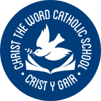
Crist y Gair
Christ the Word
Catholic School
Rhyl

Safeguarding Children and Child Protection

Christ the Word Catholic School Cefndy Road, Rhyl Denbighshire
LL18 2EU
www.christtheword.co.uk

Disclosure by a child:
Whilst this can be an alarming situation, it is important that you know what to do in such an eventuality and for you to be able to stay calm and controlled.

- Listen to what is being said without displaying shock or disbelief. Accept what is being said.
- Allow the child to talk freely, listen rather than ask direct questions.
- Re-assure the child, but do not make promises that may not be possible to keep.
- Do not promise confidentiality but explain to the child that you have to tell the appropriate person in order that you can help them.
- Do not interrogate the child or ask leading questions.
- Re-assure the child that it is not their fault.
- Stress that it was right to tell.
- Make them aware that their disclosure will be reported only to those that need to know and can help.
- Record details of the disclosure immediately, including wherever possible the exact words used by the child. Sign and date the record.
- Report your concerns and give your written record to the Designated Safeguarding Person to enable the matter to be dealt with in the
Safeguarding means preventing and protecting children and adults at risk from abuse or neglect and educating those around them to recognise the signs and dangers
Wales Safeguarding Procedures

For further information please refer to:
The school’s Safeguarding and Child Protection Policy. Keeping Learners Safe (2022)

Keeping everyone safe is impertive, that’s why Christ The Word is a nut free school.
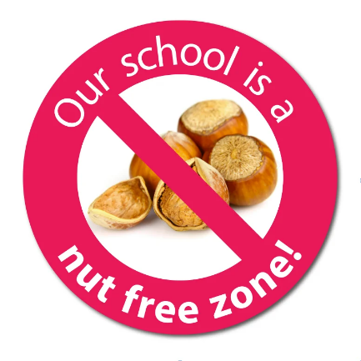

most appropriate way.
Discrimination:
The school has a zero-tolerance approach to discrimination of any kind and is working hard to ensure that the school is a community free from discrimination. If you see or hear of any kind of discriminating behaviour, please report this to a member of
staff so that this can be dealt with.

Worried about a child?
Abuse (physical, sexual, emotional) or neglect can have damaging effects on a child’s health, education attainment and emotional well-being. Some changes in a child’s behaviour may not necessarily indicate that a child is suffering abuse or neglect. In some cases those changes may be symptoms of a hidden disability, undiagnosed medical condition or changes in medication. If whilst working with a child you become concerned about:
- Comments made by a child
- Marks or bruising on a child
- Changes in a child’s behavior
- Home conditions or situations
- Appearance or dress
- Information shared by parents/carers about concerns relating to their child.
- Please report these concerns to the designated safeguarding person.
- Be aware of your own feelings about abuse and find someone you can share your feelings with once the procedures have been completed.
Allegations
Any allegations should be reported to the Designated Safeguarding Person
If the concerns are about the Safeguarding person, please inform the Headteacher. If the concerns are about the Headteacher, please inform the Chair of Governors.
- It is important to remember the child’s details and names must remain confidential and any discussion that you feel you need to undertake does not allow the child to be identified to anyone else.

